Religion in America:
One Nation, Under God(s)?
PHRE-410 / Fall 2017
Phillips Academy
Mr. Prescott

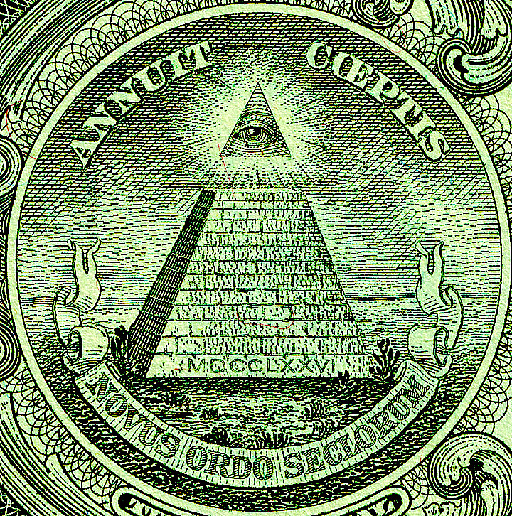

Instructor: Mr. Prescott
Location: Chapel 015
Email: kprescott@andover.edu
Office: (978) 749-4136
Cell: (207) 504-6512

Course Description

In contemporary American public life, religion is everywhere, and the United States is considered one of the most religious countries in the world. This course will examine the role of religion in American history and politics, from colonial times to the present day. Questions to be addressed include: Is American a Christian country? What role did religion play in the founding of America? Did the founding documents seek to create a separation of church and state? How were religious arguments used to justify or challenge slavery? What are the causes of the rise of fundamentalism in the 20th century? What, looking forward, is America’s religious identity in an increasingly diverse and pluralistic society?

Course Requirements, Evaluation, and Policies

I. Required Text(s):

1. Eboo Patel, Sacred Ground: Pluralism, Prejudice, and the Promise of America (Boston: Beacon Press, 2012).
2. Additional texts will be made available in class and posted on Canvas

II. Evaluation

i. Class Discussion (30%) – Much of this class will proceed as a seminar, which means careful reading of assigned work, regular attendance, and participation in class discussion are all essential in order to succeed in the course. A separate handout/rubric will be provided regarding expectations for classroom participation/discussion.

ii. Reflection Papers (10%) – In order to aid the process of understanding in the course, students are expected to complete one reflection paper per week on a reading of their choosing (no more than one page). These are graded on a Complete/Incomplete/Missing basis.

iii. Essays/Projects (60%) – Two different analytical/argumentative essays (appx. 3-5 pages in length) will be assigned at the conclusion of the first two units, while the course itself will culminate in a curatorial project, where students will be asked to design a mini-exhibition on a theme of their choosing. More specific information about the nature of these assignments will be provided closer to their corresponding due dates.

- Unit 1 Essay (15%) – Due on Wednesday, October 4
- Unit 2 Essay (20%) – Due on Tuesday, October 31
- Curatorial Project (25%) – Due on Tuesday, November 14

III. Extensions – Generally speaking, I do not grant extensions. In addition to allocating class time for papers, prompts are also handed out at least one week in advance of the due date, so the expectation is that students will plan ahead and manage their time appropriately. The only exception to this policy is when a student has three or more major assignments due on the same day, in which case students are expected to follow the protocols outlined on p. 51 of the Blue Book under “Workload & Assignments” (which includes 24-hours advance notice).

IV. Late Work Policy – All written assignments are due by the beginning of class. Any work handed in after this point will be counted as late. Please note that technological difficulties are not an excuse for lateness. Anticipate that the printer will break, that files will be lost, or that your computer will die! Any work handed in after the due date will receive a grade no higher than a 3+. Work that is handed in more than one week past the due late will not receive credit.

IV. Rewrite Policy – All essays that receive a grade of 3- or lower must be rewritten. Additionally, students may choose to revise either of the first two papers, though revisions must be substantial; it is not sufficient simply to plug in the instructor’s feedback. Students must also complete a revision reflection to be handed in with the revised paper. The grade for the rewrite will be averaged with the first grade to determine the final grade for the assignment. All rewrites are due one week after the initial essay is returned. Please note that I do not accept rewrites for unauthorized late essays.

VI. Absences - As noted above under Classroom Preparation/Participation, regular attendance is essential if one is to succeed in this course! However, I realize that this course is not your only commitment this term, just as I realize that circumstances inevitably arise that our outside of your control. First and foremost, I ask that you communicate with me (the earlier the better). Please note that students are responsible for all announcements or changes made in class. Regarding Personal Time, I ask that students follow the procedures outlined on pp. 54-55 of the Blue Book (note that personal time is not available to lowers during the fall term). Finally, in the event that an assignment is due on the day a student is sick (with an excused absence from the Health Center), said assignment will be due at the beginning of the next class meeting.

VI. E-mail – I will respond to all e-mail within 24 hours. However, please note that any e-mail sent after 7:00 PM will not receive a response until the following morning, so please plan ahead!

VIII. Religious Observances – Some students may wish to take part in religious observances that fall during the term. Should you have a religious observance that conflicts with participation in the course, please contact me as soon as possible to discuss appropriate accommodations.

IX. Disabilities – Students with learning, physical, or psychiatric disabilities who may require disability-related classroom accommodations are encouraged to see me as soon as possible to discuss your particular needs. All discussions will remain confidential, though I may consult Student Health Services to discuss appropriate implementation of any accommodation requested.

X. Technology – Although we live in an increasingly digitized world, please note that I do not allow the use of computers/tablet/phones during class unless otherwise specified.

Schedule of Assignments
(Subject to Change)
Unit 1: Religion and the Founding of the United States

Thursday, September 7 – Introduction and Course Overview
- No assigned readings

Week 1 – The American Religious Landscape

Monday, September 11 – Reading in Religious Studies: Skills and Strategies
- No assigned readings

Tuesday, September 12 – The American Religious Landscape
- Read: Robert D. Putnam and David E. Campbell, "Religious Polarization and Pluralism in America," in American Grace: How Religion Divides and Unites Us (New York: Simon & Schuster, 2010), pp. 1-32.

Wednesday, September 13 – Myths and American Origins
- Read: Bruce Lincoln, “Mythic Narrative and Cultural Diversity in American Society,” in Myth and Method, eds. Laurie L. Patton and Wendy Doniger (Charlottesville, VA: University of Virginia Press, 1996), 163-176.

Friday, September 15 – Friday Free (No Class)

Week 2 – Religion and American Colonization

Tuesday, September 19 – Religion and the Colonies
- Read: Steven Waldman, “Christian America,” in Founding Faith: Providence, Politics, and the Birth of Religious Freedom in America (New York: Random House, 2008), 3-17.

Wednesday, September 20 – Colonial Speed Dating
- Read: Primary Source Documents

Friday, September 22 – Thomas Jefferson and Enlightenment Rationalism
- Read: The Declaration of Independence
- Read: Steven Waldman, “Thomas Jefferson: The Pious Infidel,” in Founding Faith: Providence, Politics, and the Birth of Religious Freedom in America (New York: Random House, 2008), 72-85.

Week 3 – The Myth of America’s Founding

Monday, September 25 – The First Amendment Compromise
- Read: Article VI and the First Amendment of the U.S. Constitution
- Read: Steven Waldman, “The First Amendment Compromise: Building a wall that looks good from all sides,” Founding Faith: Providence, Politics, and the Birth of Religious Freedom in America (New York: Random House, 2008), 141-158.

Tuesday, September 26 – The Deification of Washington
- Read: Steven Waldman, Founding Faith: Providence, Politics, and the Birth of Religious Freedom in America (New York: Random House, 2008), selections.

Wednesday, September 27 – Writing Workshop
- No assigned readings

Friday, September 29 – Release Time
- Class will note meet; work on essays

Week 4: The Myth of American Origins

Tuesday, October 3 – Writing Workshop
- No assigned readings

Wednesday, October 4 – The Myth of America’s Founding
- Due: Essay #1

Friday, October 6 – No Class

Unit 2: Religious Intolerance in America

Week 5: “Dirt” and Religious Intolerance

Monday, October 9 – No Class

Tuesday, October 10 – Religious Intolerance and Secular Defilement
- Read: Mary Douglas, “Secular Defilement,” in Purity and Danger (New York: Routeldge, 1966), 36-50.
- Note: Reflection paper due this week
- Note: Today runs on a Wednesday schedule

Wednesday, October 11 – No Class (PSATs)

Friday, October 13 – Religious Intolerance in the Twenty-First Century
- Read: Eboo Patel, “Introduction,” in Sacred Ground: Pluralism, Prejudice, and the Promise of America (Boston, MA: Beacon Press, 2012), xi-xxix.
- Note: Reflection paper due this week

Week 6: Religious Intolerance in America

Monday, October 16 – No Class

Tuesday, October 17 – Islamaphobia and Cordoba House
- Read: Eboo Patel, “Ground Zero,” in Sacred Ground: Pluralism, Prejudice, and the Promise of America (Boston, MA: Beacon Press, 2012), 3-22.
- Note: Reflection paper due this week

Wednesday, October 18 – The Catholic Menace
- Read: Eboo Patel, “The Muslim Menace,” in Sacred Ground: Pluralism, Prejudice, and the Promise of America (Boston, MA: Beacon Press, 2012), 23-40.
- Note: Reflection paper due this week

Friday, October 20 – The Rise of the Religious Right
- Read: Eboo Patel, “The Evangelical Shift,” in Sacred Ground: Pluralism, Prejudice, and the Promise of America (Boston, MA: Beacon Press, 2012), 41-64.
- Note: Reflection paper due this week

Week 7: Religious Intolerance and American Politics

Monday, October 23 – Family Weekend (No Class)

Tuesday, October 24 – The American Civil Religion
- Read: State of Indiana Religious Freedom Restoration Act

Wednesday, October 25 – The Civil Religion and Inauguration Speeches
- Read: Donald J. Trump, “First Inaugural Address,” January 20, 2017
- Read: Barack H. Obama, “First Inaugural Address,” January 20, 2009
- Read: John F. Kennedy, “First Inaugural Address,” January 20, 1961
- Read: Abraham Lincoln, “Second Inaugural Address,” March 4, 1865

Friday, October 27 – Writing Workshop
- No assigned readings

Unit 3: Final Projects

Week 8: The Curatorial Challenge of Religion and America

Tuesday, October 31 – The Civil Religion: Inclusive or Exclusive?
- Due: Essay #2

Wednesday, November 1 – Brainstorm Workshop
- No assigned readings

Friday, November 3 – Brainstorm Workshop
- Due: Exhibit Artifacts and Primary Theme

Week 9: Final Project Research

Tuesday, November 7 – Research Workshop
- Due: Additional Artifacts

Wednesday, November 8 – Research Workshop
- No assigned readings

Friday, November 10 – Research Workshop
- No assigned readings

Week 10: Finals Period

Monday, November 13 – Conference Period
- Work on final project; Mr. Prescott available

Tuesday, November 14 – Final Presentations
- Final Project Due

Bibliography

Robert Bellah, “Civil Religion in America,” Daedalus 117.3 (1988): 97-118.

Douglas, Mary. Purity and Danger. New York: Routeldge, 1966.

Lincoln, Bruce. “Mythic Narrative and Cultural Diversity in American Society.” Myth and Method. Eds. Laurie L. Patton and Wendy Doniger. Charlottesville, VA: University of Virginia Press, 1996. 163-176.

Patel, Eboo. Sacred Ground: Pluralism, Prejudice, and the Promise of America. Boston: Beacon Press, 2012.

Putnam, Robert D. and David E. Campbell. American Grace: How Religion Divides and Unites Us. New York: Simon & Schuster, 2010.

Waldman, Steven. Founding Faith: Providence, Politics, and the Birth of Religious Freedom in America. New York: Random House, 2008.

