Religion in America:
One Nation, Under God(s)?
PHRE-410 / Fall 2016
Phillips Academy
Mr. Prescott

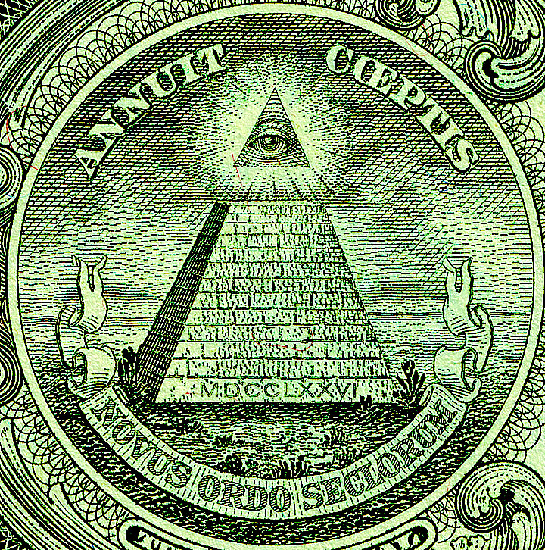

Instructor: Mr. Prescott
Location: Chapel 016
Email: kprescott@andover.edu
Office: (978) 749-4136
Cell: (207) 504-6512

Course Description

In contemporary American public life, religion is everywhere, and the United States is considered one of the most religious countries in the world. This course will examine the role of religion in American history and politics, from colonial times to the present day. Questions to be addressed include: Is American a Christian country? What role did religion play in the founding of America? Did the founding documents seek to create a separation of church and state? How were religious arguments used to justify or challenge slavery? What are the causes of the rise of fundamentalism in the 20th century? What, looking forward, is America’s religious identity in an increasingly diverse and pluralistic society?

Course Requirements, Evaluation, and Policies

I. Required Text(s):

1. Eboo Patel, Sacred Ground: Pluralism, Prejudice, and the Promise of America.
2. Vine Deloria Jr., God Is Red: A Native View of Religion
3. Additional texts will be made available in class and posted on Canvas

II. Evaluation

i. Classroom Preparation/Participation (25%) – Much of this class will proceed as a seminar, which means regular attendance, participation in class, and careful reading of assigned texts are all essential in order to succeed in the course. Indeed, it is not enough to merely run our eyes over the pages: we must be active in our effort to understand what we are reading. In order aid this process, students will be asked to complete 1-page reflection papers in conjunction their readings (generally speaking, one per week on a night of the student's choosing). A separate handout on reflection papers will be provided. Additional prompts will also be assigned in-class throughout the term, which will also be factored into the participation grade.

ii. Essays/Projects (75%) – Two different analytical/argumentative essays (appx. 4-6 pages in length) will be assigned at the conclusion of the first two units. More specific information about the nature of these essays will be provided closer to their corresponding due dates. The final unit will culminate in a collaborative project with the Peabody Museum of Archaeology (details forthcoming!).

- Unit 1 Essay (20%) – Due on Tuesday, October 4
- Unit 2 Essay (25%) – Due on Tuesday, October 25
- Museum Project (30%) – Due on Friday, November 18

III. Late Work Policy – The baseline expectation is that all written assignments will be handed in at the beginning of class on the date they are due (not 15 minutes after class has started). If a student has a scheduling conflict or multiple major assignments due on the same date, it is the student’s responsibility to speak to me beforehand about appropriate accommodations (the earlier the better). An e-mail the night before is not sufficient. Also, please note that technological difficulties are not an excuse for lateness. Anticipate that the printer will break, that files will be lost, or that your computer will die! Any work handed in after the due date will receive a grade no higher than a 4.

IV. Rewrite Policy – All essays that receive a grade of 3- or lower must be rewritten. In addition, all students may choose to rewrite one essay per term. Revisions must be substantial; it is not sufficient simply to plug in the instructor’s feedback. The grade for the rewrite will be averaged with the first grade to determine the final grade for the assignment. All rewrites are due one week after the initial essay is returned. Please note that I do not accept rewrites for unauthorized late essays.

V. Absences - As noted above under Classroom Preparation/Participation, regular attendance is essential if one is to succeed in this course. However, I realize that this course is not your only commitment this term, just as I realize that circumstances inevitably arise that our outside of your control. First and foremost, I ask that you communicate (the earlier the better). Please note that students are responsible for all announcements or changes made in class. Last, in the event that an assignment is due on the day a student is sick (with an excused absence from the Health Center), said assignment will be due at the beginning of the next class meeting.

VI. E-mail – I will respond to all e-mail within 24 hours. However, please note that any e-mail sent after 8:00 PM will not receive a response until the following morning, so please plan ahead!

VII. Religious Observances – Some students may wish to take part in religious observances that fall during the term. Should you have a religious observance that conflicts with participation in the course, please contact me as soon as possible to discuss appropriate accommodations.

VIII. Disabilities – Students with learning, physical, or psychiatric disabilities who may require disability-related classroom accommodations are encouraged to see me as soon as possible to discuss your particular needs. All discussions will remain confidential, though I may consult Student Health Services to discuss appropriate implementation of any accommodation requested.

Unit 1: Is America a Christian Nation?
(Please note that readings are subject to change!)

Thursday, September 8 – Introduction and Course Overview
- No assigned readings

Week 1 – Religion and Colonial America

Tuesday, September 13 – Is America a Christian Nation?
- Read: Robert Bellah, “Civil Religion in America,” Journal of the American Academy of Arts and Sciences 96.1 (1967): 1-21.

Wednesday, September 14 – Religion and the Colonies
- Read: Steven Waldman, “Christian America,” Founding Faith: Providence, Politics, and the Birth of Religious Freedom in America (New York: Random House, 2008), 3-17.

Friday, September 16 – Founding Fathers: James Madison
- Read: Steven Waldman, “James Madison: The Radical Pluralist” and “A Diabolical Persecution,” Founding Faith (New York: Random House, 2008), 94-106.

Week 2 – The Founding Fathers and the U.S. Constitution

Tuesday, September 20 – Founding Fathers: Thomas Jefferson
- Read: Steven Waldman, “Thomas Jefferson: The Pious Infidel,” Founding Faith (New York: Random House, 2008), 72-85.

Wednesday, September 21 – Founding Fathers: Adams, Franklin, & Washington
- Group 1: Steven Waldman, “John Adams: The Angry Unitarian,” Founding Faith: Providence, Politics, and the Birth of Religious Freedom in America (New York: Random House, 2008), 33-39.
- Group 2: Steven Waldman, “George Washington: Protected by God,” Founding Faith: Providence, Politics, and the Birth of Religious Freedom in America (New York: Random House, 2008), 56-63.
- Group 3: Steven Waldman, “Benjamin Franklin: The Puritan New Ager,” Founding Faith: Providence, Politics, and the Birth of Religious Freedom in America (New York: Random House, 2008), 18-26.

Friday, September 23 – The First Amendment
- Read: Steven Waldman, “The First Amendment Compromise: Building a wall that looks good from all sides,” Founding Faith: Providence, Politics, and the Birth of Religious Freedom in America (New York: Random House, 2008), 141-158.

Week 3 – The First Amendment in Practice

Tuesday, September 27 – Case Study: Everson v. Board of Education
- Read: Everson v. Board of Education. 1947 330 U.S. 1. United States Supreme Court.

Wednesday, September 28 – Debate: Everson v. Board of Education
- Prepare for debate!

Friday, September 30 – Is the Civil Religion Dead?
- Read: Yoni Applebaum, “America’s First Post-Christian Debate,” The Atlantic (September 27, 2016).

Unit 2: Religious Intolerance & Pluralism

Week 4: What Causes Religious Intolerance?

Tuesday, October 4 – Writing Workshop
- No assigned readings

Wednesday, October 5 – Religious Stereotypes and Bias
- Due: Essay

Friday, October 7 – Religious Intolerance in America
- Read: Eboo Patel, “Introduction,” Sacred Ground: Pluralism, Prejudice, and the Promise of America (Boston, MA: Beacon Press, 2012), xi-xxix.

Week 5: Religious Intolerance in the 21st Century

Monday, October 10 – Islamaphobia and Cordoba House
- Read: Eboo Patel, “Ground Zero,” in Sacred Ground: Pluralism, Prejudice, and the Promise of America (Boston, MA: Beacon Press, 2012), 3-22.

Tuesday, October 11 – The Catholic Menace
- Read: Eboo Patel, “The Muslim Menace,” in Sacred Ground: Pluralism, Prejudice, and the Promise of America (Boston, MA: Beacon Press, 2012), 23-40.

Friday, October 14 – The Rise of the Religious Right
- Read: Eboo Patel, “The Evangelical Shift,” in Sacred Ground: Pluralism, Prejudice, and the Promise of America (Boston, MA: Beacon Press, 2012), 41-64.

Note: Midterm Grades Due on October 16

Week 6: The Challenge of Pluralism

Monday, October 17 – The Science (and Art) of Interfaith Cooperation
- Read: Eboo Patel, “The Science of Interfaith Cooperation” and “the Art of Interfaith Leadership,” in Sacred Ground: Pluralism, Prejudice, and the Promise of America (Boston, MA: Beacon Press, 2012), 74-80, 88-103.

Tuesday, October 18 – Interfaith Cooperation: A Call to Prayer
- Read: Ellie Pierce, “A Call to Prayer (A),” The Pluralism Project (Harvard University, 2015).

Friday, October 21 – Proposal Workshop
- Due: Rough draft of Interfaith Proposal

Unit 3: Native American Religious Identity

Week 7: Indians in the Eyes of America

Tuesday, October 25 – Indians of the American Imagination
- Due: Essay #2
Wednesday, October 26 – Colonial Views of Native Americans
- Read: Vine Deloria Jr., “The Indians of the American Imagination,” God is Red: A Native View of Religion (Golden, CO: Fulcrum Publications, 2003), 23-44.
- Note: Class will meet at the Peabody Museum

Friday, October 28 – Epistemological Decolonization: Thinking in Time & Space
- Read: Vine Deloria Jr., “Thinking in Time and Space,” God is Red: A Native View of Religion (Golden, CO: Fulcrum Publications, 2003), 61-75.

Week 8: The Challenge of Responsible Curation

Tuesday, November 1 – A Return to Sacred Ground
- Read: Vine Deloria Jr., “Sacred Places and Moral Responsibility,” God is Red: A Native View of Religion (Golden, CO: Fulcrum Publications, 2003), 271-285.

Wednesday, November 2 – NAGPRA: A Case Study
- Read: Amy Lonetree, “Introduction: Native Americans and Museums,” Decolonizing Museums: Representing Native America in National and Tribal Museums (Chapel Hill, NC: University of North Carolina Press, 2012), 4-21.
- Note: Class will meet at the Peabody Museum

Friday, November 4 – Jigsaw: Responsible Curation
- Group 1: Amy Lonetree, “Collaboration Matters: The Minnesota Historical Society, the Mille Lacs Band of Obijwe, and the Creation of a ‘Hybrid Tribal Museum’,” Decolonizing Museums: Representing Native America in National and Tribal Museums (Chapel Hill, NC: University of North Carolina Press, 2012), 33-37, 48-64.
- Group 2: Amy Lonetree, “Exhibiting Native America at the National Museum of the American Indian,” Decolonizing Museums: Representing Native America in National and Tribal Museums (Chapel Hill, NC: University of North Carolina Press, 2012), 78-82, 107-122.

Week 9: Native American Objects and the Peabody

Tuesday, November 8 – Native American Voices: Guest Lecturer Blythe George
- Read: Paul Nadasdy, “The Gift in the Animal: The Ontology of Hunting and Human-Animal Sociality,” American Ethnologist 34.1 (February 2007): 25-43.

Wednesday, November 9 – Research Workshop
- Note: Class will meet at OWHL

Friday, November 11 – Project Workshop
- Due: Project Outline and Preliminary Bibliography (min. seven sources)

Week 10: Finals Period

Monday, November 14 – Conference Period
- Work on final project; Mr. Prescott available for conferences during Period 1 and via appointment

Wednesday, November 16 – Research Workshop
- Work on final project

Friday, November 18 – Final Projects Due
- Due: Final Paper and Object Summary
Bibliography

Applebaum, Yoni. “America’s First Post-Christian Debate.” The Atlantic. September 27, 2016.

Corrigan, John, and Lynn S. Neal, eds. Religious Intolerance in America: A Documentary History. Chapel Hill, NC: University of North Carolina Press, 2010.

Deloria, Vine, Jr. God is Red: A Native View of Religion. 30th Anniversary Ed. Golden, CO: Fulcrum Publishing, 2003.

Everson v. Board of Education. 1947 330 U.S. 1. United States Supreme Court.

Gaustad, Edwin S. A Documentary History of Religion in America to the Civil War. Second Ed. Grand Rapids, MI: William B. Eerdmans, 1993.

Lambert, Frank. Religion in American Politics: A Short History. Princeton, NJ: Princeton University Press, 2008.

Lonetree, Amy. Decolonizing Museums: Representing Native America in National and Tribal Museums. Chapel Hill, NC: University of North Carolina Press, 2012.

Nadasdy, Paul. “The Gift in the Animal: The Ontology of Hunting and Human-Animal Sociality.” American Ethnologist 34.1 (February 2007): 25-43.

Pierce, Ellie. “A Call to Prayer (A).” The Pluralism Project. Harvard University, 2015.

Patel, Eboo. Sacred Ground: Pluralism, Prejudice, and the Promise of America. Boston: Beacon Press, 2012.

Waldman, Steven. Founding Faith: Providence, Politics, and the Birth of Religious Freedom in America. New York: Random House, 2008.

