The Bible & Its Contexts
PHR-330 / Spring 2018
Phillips Academy
Mr. Prescott

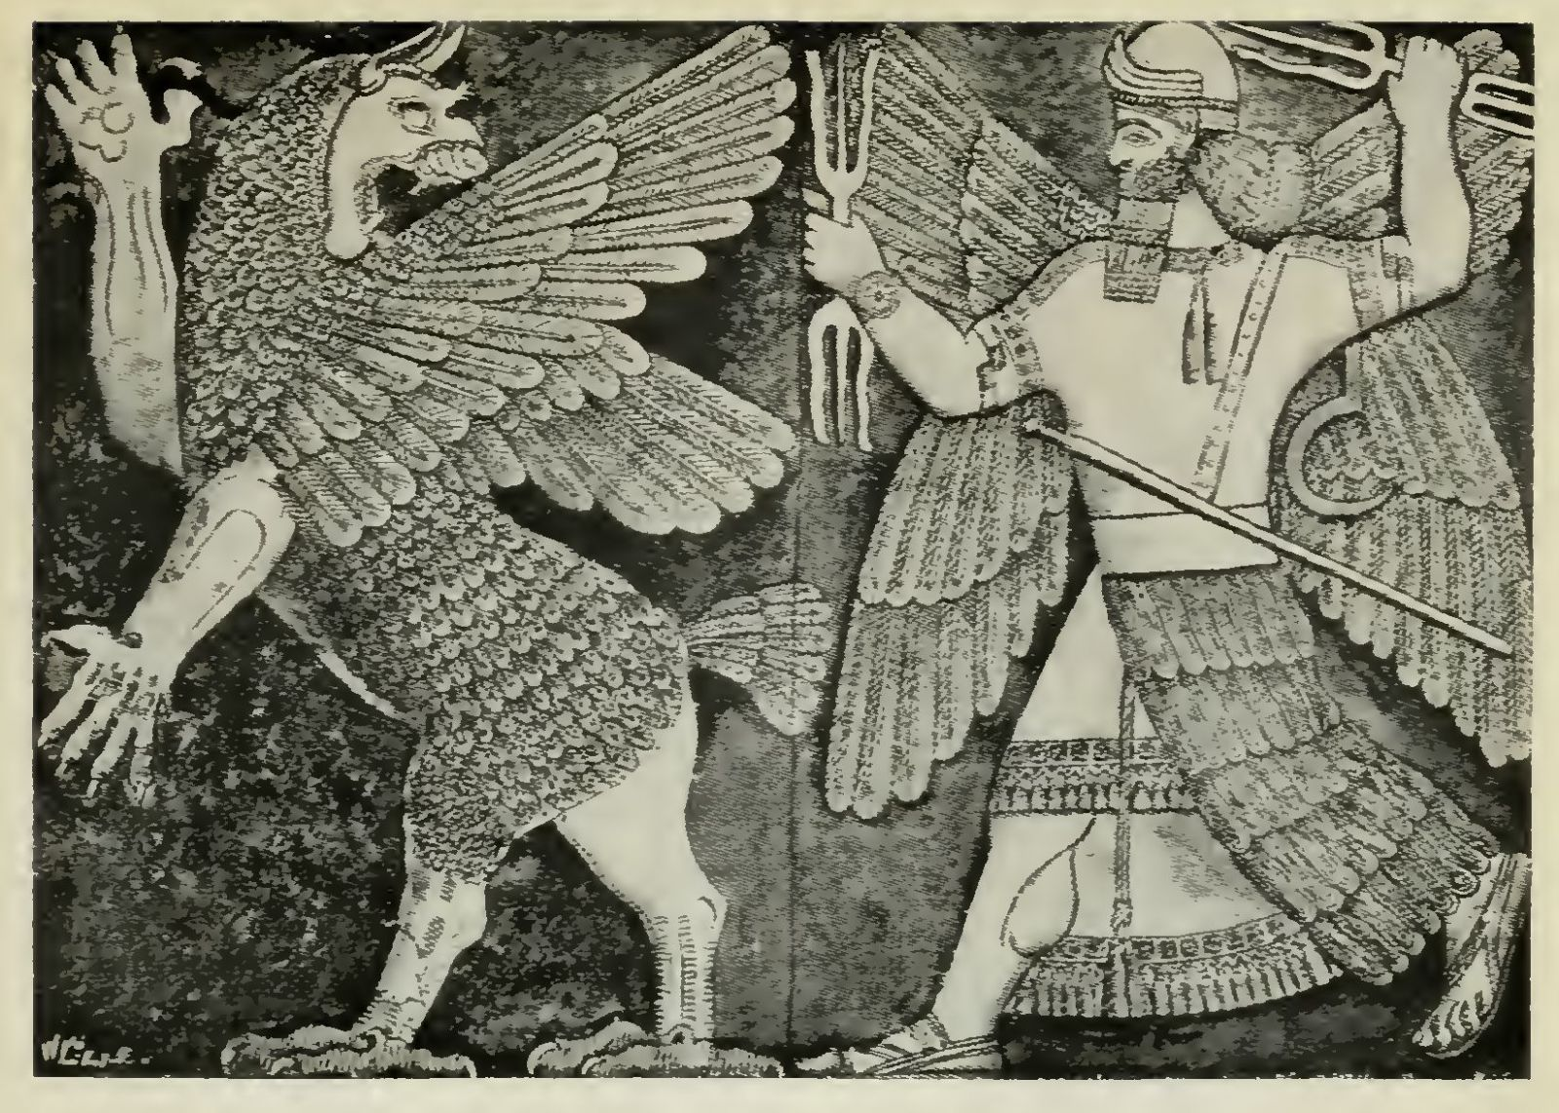

Instructor: Mr. Prescott
Location: Chapel 015
Email: kprescott@andover.edu

Course Description

No text that has been more influential in shaping the course of human history than that of the Bible, not only informing the major monotheistic traditions of Christianity, Judaism, and Islam, but also western culture as a whole. Yet, the origins of the biblical text are surprisingly enigmatic. For starters, the Bible is a composite text, or the product of many different hands over the course of hundreds of years, as opposed to one author at one time, resulting in a wide range of perspectives that respond to many different religious, political, social, and cultural circumstances from multiple time periods. When it comes to understanding the Bible then, context matters.

As such, the primary aim of this course will be to orient students toward the various religious, political, social, and cultural contexts that shaped the formation of the biblical text. Who were the biblical authors? How did their biases shape what was (and wasn’t) included in the biblical narrative? Is there only one God? Did God have a wife? Who was Mary Magdalene and what was her role in early Christianity? How does the biblical narrative continue to shape the manner in which we think today? This course assumes no prior understanding of or engagement with the biblical text.

Course Requirements, Evaluation, and Policies

I. Required Texts:

- Harold W. Attridge and Wayne A. Meeks, eds., HarperCollins Study Bible: New Revised Standard Version, Including the Apocryphal/Deuterocanonical Books (New York: HarperCollins, 1989).
- Additional texts will be made available in class and posted on Canvas

II. Evaluation

i. Classroom Participation (20%) – Much of this class will proceed as a seminar, which means careful reading of assigned work, regular attendance, and participation in class are all essential in order to succeed in the course. A separate handout/rubric will be distributed regarding expectations for classroom participation/discussion.

ii. Reading Quizzes/Prompts (10%) – Short reading quizzes and writing prompts will be given in-class throughout the term. These are not meant to be comprehensive, but rather help students establish a foundation for larger writing assignments.

ii. Major Assignments (70%) – Two exams will be given in the first half of the course, which will assess baseline understanding of both the biblical text and its historical contexts. The second half of the course will feature two argumentative essays. More information will be provided at a later date.

- Unit 1 Exam (10%) – Thursday, April 5
- Unit 2 Exam (15%) – Thursday, April 19
- Unit 3 Essay (20%) – Due Thursday, May 10
- Unit 4 Essay (25%) – Due Wednesday, May 30

III. Extensions – Generally speaking, I do not grant extensions. In addition to allocating class time for papers, prompts are also handed out at least one week prior to the due date, so the expectation is that students will plan ahead and manage their time appropriately. The only exception to this policy is when a student has three or more major assignments due on the same day, in which case students are expected to follow the protocols outlined on p. 51 of the Blue Book under “Workload & Assignments” (which includes 24-hours advance notice).

IV. Late Work Policy – All written assignments are due at the beginning of class (please upload to Canvas). Any work handed in after this point will be counted as late. Please note that problems with technology are not an excuse for lateness. Anticipate that the printer will break, that files will be lost, or that your computer will die! Any work handed in after the due date will receive a grade no higher than a 3+.

V. Revision Policy – Students interested in revising either exams or essays should meet with the instructor. In the event of a revision, the grade for the revision will be averaged with the initial grade to determine the new grade for the assignment. Revisions must be completed no more than one week after the initial assignment is returned. Please note that I do not accept rewrites for unauthorized late work.

VI. Absences - As noted above under Classroom Preparation/Participation, regular attendance is essential if one is to succeed in this course! However, I realize that this course is not your only commitment this term, just as I realize that circumstances inevitably arise that our outside of your control. First and foremost, I ask that you communicate with me (the earlier the better). Please note that students are responsible for all announcements or changes made in class. Regarding Personal Time, I ask that students follow the procedures outlined on pp. 54-55 of the Blue Book. Finally, in the event that an assignment is due on the day a student is sick (with an excused absence from the Health Center), said assignment will be due at the beginning of the next class meeting.

VII. E-mail – I will respond to all e-mail within 24 hours. However, please note that any e-mail sent after 7:00 PM will not receive a response until the following morning, so plan ahead!

VIII. Religious Observances – Some students may wish to take part in religious observances that fall during the term. Should you have a religious observance that conflicts with participation in the course, please contact me as soon as possible to discuss appropriate accommodations.

IX. Disabilities – Students with learning, physical, or psychiatric disabilities who may require disability-related classroom accommodations are encouraged to see me as soon as possible to discuss your particular needs. All discussions will remain confidential, though I may consult Student Health Services to discuss appropriate implementation of any accommodation requested.

X. Technology – Although we live in an increasingly digitized world, please note that I do not allow the use of computers/tablet/phones during class unless otherwise specified.

Schedule of Assignments
(Subject to Change)
Unit 1: The Bible in Context

Week 1 – Introduction to the Biblical Text

Tuesday, March 20 – Introduction & Overview
- No assigned readings

Thursday, March 22 – in the Beginning…
- Read: Gen 1:1-2:4 (multiple translations; see Canvas for more details)

Friday, March 23 – Class Does Not Meet

Week 2 – The World of the Bible

Monday, March 26 – Class Does Not Meet
- No assigned readings

Thursday, March 29 – A Second Creation
- Read: Gen 2:4-3:24

Friday, March 30 – Who Wrote the Bible?
- Read: Richard Elliot Friedman, "Introduction: Who Wrote the Bible?" in Who Wrote the Bible? (San Francisco: HarperSanFrancisco, 1987), pp. 15-27.

Unit 2: Who Wrote the Bible?

Week 3 – The Documentary Hypothesis

Monday, April 2 – The Geography of Ancient Israel
- Due: Richard Elliot Friedman, "The World that Produced the Bible: 1200-722 BC" in Who Wrote the Bible? (New York: HarperCollins, 1987), pp. 33-36

Tuesday, April 3 – The (Brief) History of Ancient Israel
- Due: Richard Elliot Friedman, "The World that Produced the Bible: 1200-722 BC" in Who Wrote the Bible? (New York: HarperCollins, 1987), pp. 37-49

Thursday, April 5 – Unit 1 Exam
- No assigned readings

Friday, April 6 – Who is the Yahwist?
- Read: Genesis 4:1-25; 11:1-9; 18:1-19:38

Week 4 – The Biblical Authors

Monday, April 9 – Who is the P-Source?
- Read: Gen 17:1-27; Ex 20:1-17; 25:1-22; 26:1-37; 29:1-46
- Due: Short Prompt

Thursday, April 12 – Who Is the Elohist
- Read: 1 Kings 12:20-33; Exodus 32:1-33:11; Numbers 12:1-16

Friday, April 13 – Release Time (No Class)
- No assigned readings
Week 5 – Midterms

Tuesday, April 17 – When Sources Collide
- Read: Gen 6:1-9:28

Thursday, April 19 – Release Time (No Class)
- No assigned readings

Friday, April 20 – Non Sibi Days (No Class)
- Class will not meet

Unit 3: The Exodus and Interpretative Context

Week 6 – Determining Authorial Intent

Monday, April 23 – Unit 1 Exam: Part 1
- Due: Unit 1 Exam

Tuesday, April 24 – Unit 1 Exam: Part 2
- Due: Unit 1 Exam

Thursday, April 26 – The Exodus From Egypt
- Read: Ex 1:1-8:15; 11:1-15:31;l skim 8:16-10:29

Friday, April 27 – The Conquest of Canaan
- Read: Joshua 1:1-8:29

Week 7 – The Bible in Context

Monday, April 30 – A Native American Perspective
- Read: Robert Allan Warrior, “A Native American Perspective: Canaanites, Cowboys, and Indians,” Biblical Studies Alternatively: An Introductory Reader, ed. Susanne Scholz (Upper Saddle River, NJ: Prentice Hall, 2003), pp. 400-405.

Thursday, May 3 – TBD
- Read:

Friday, May 4 – Writing Workshop
- Due: Essay Outline

Unit 4: The New Testament and Canon Formation

Week 7 – Introduction to the New Testament

Monday, May 7 – Release Time
- Note: Class will not meet; work on essays

Thursday, May 10 – Due: Essay #1
- Due: Unit #3 Essay

Friday, May 11 – Friday Free
- Note: Class does not meet

Week 8 – Women and the Bible

Monday, May 14 – The Life and Death of Jesus Christ
- Read: Selections from the Gospels

Thursday, May 17 – Women and the Pauline Corpus
- Read: Romans 16, pp. 1930-31; First Corinthians 7:1-11, p. 1940; 11:1-16, pp. 1946-47; 1433b-36, p. 1952; Galatians 3:26-28, p. 1978; Philippians 4:2-3, p. 1996; Colossians 3:18-4:1, pp. 2003-04; 4:15, p. 2004; First Timothy 2:8-15, p. 2018

Friday, May 18 – The Gospel of Mary Magdalene
- Read: Karen L. King, “Introduction,” The Gospel of Mary of Magdala: Jesus and the First Woman Apostle (Santa Rosa, CA: Polebridge Press, 2003), pp. 3-12.
- Read: The Gospel of Mary Magdalene

Week 9 – The Apocrypha

Monday, May 21 – The Acts of Paul and Thecla
- Read: J.K. Elliott, ed., “The Acts of Paul and Thecla,” The Apocryphal New Testament: A Collection of Apocryphal Christian Literature in an English Translation (Oxford: Clarendon Press, 1993), pp. 364-372.

Thursday, May 24 – Female Ordination in the Modern Church
- Read: TBD

Friday, May 25 – Writing Workshop
- Due: Rough Draft

Week 10 – Finals Week

Tuesday, May 30 – Conference Period

Wednesday, May 30 – Essay #2 Due
- Due: Unit #4 Essay

Bibliography

Elliott, J.K. “The Acts of Paul and Thecla.” The Apocryphal New Testament: A Collection of Apocryphal Christian Literature in an English Translation. Oxford: Clarendon Press, 1993. 364-372.

Friedman, Richard Elliott. Who Wrote the Bible? New York: HarperCollins, 1997.

The Gnostic Society Library. “The Gospel According to Mary Magdalene.” The Gnostic Society Library. < http://gnosis.org/library/marygosp.htm>.

King, Karen L. The Gospel of Mary of Magdala: Jesus and the First Woman Apostle. Santa Rosa, CA: Polebridge Press, 2003.

Warrior, Robert Allan. “A Native American Perspective: Canaanites, Cowboys, and Indians.” Biblical Studies Alternatively: An Introductory Reader. Ed. Susanne Scholz. Upper Saddle River, NJ: Prentice Hall, 2003. 400-405.

