The Bible & Its Contexts
PHRE-330 / Spring 2017
Phillips Academy
Mr. Prescott

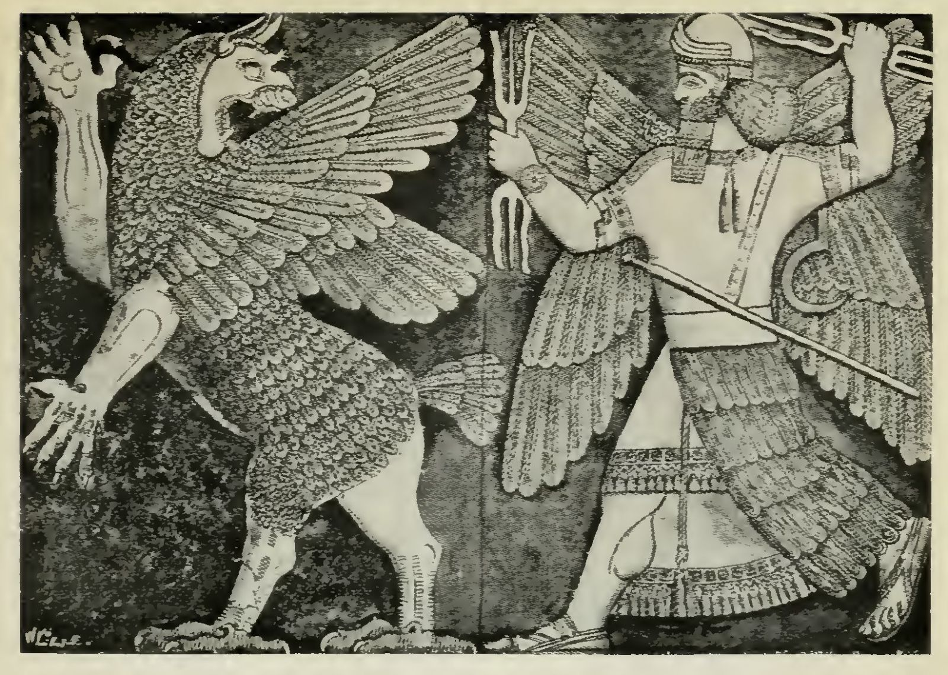

Instructor: Mr. Prescott
Location: Chapel 015
Email: kprescott@andover.edu
Office Phone: (978) 749-4136
Cell Phone: (207) 504-6512

Course Description

No text that has been more influential in shaping the course of human history than that of the Bible, not only informing the major monotheistic traditions of Christianity, Judaism, and Islam, but also western culture as a whole. Yet, the origins of the biblical text are surprisingly enigmatic. For starters, the Bible is a composite text, or the product of many different hands over the course of hundreds of years, as opposed to one author at one time, resulting in a wide range of perspectives that respond to many different religious, political, social, and cultural circumstances from multiple time periods. When it comes to understanding the Bible then, context matters.

As such, the primary aim of this course will be to orient students toward the various religious, political, social, and cultural contexts that shaped the formation of the biblical text. Who were the biblical authors? How did their biases shape what was (and wasn’t) included in the biblical narrative? Is there only one God? Did God have a wife? Who was Mary Magdalene and what was her role in early Christianity? How does the biblical narrative continue to shape the manner in which we think today? This course assumes no prior understanding of or engagement with the biblical text.

Course Requirements, Evaluation, and Policies

I. Required Texts:

- Harold W. Attridge and Wayne A. Meeks, eds., HarperCollins Study Bible: New Revised Standard Version, Including the Apocryphal/Deuterocanonical Books (New York: HarperCollins, 1989).
- Andrew George, trans., The Epic of Gilgamesh (New York: Penguin, 1999).
- Additional texts will be made available in class and posted on Canvas

II. Evaluation

i. Classroom Participation (30%) – Much of this class will proceed as a seminar, which means careful reading of assigned work, regular attendance, and participation in class are all essential in order to succeed in the course. A separate handout/rubric will be distributed regarding expectations for classroom participation/discussion.

ii. Essays (70%) – Several different analytical/argumentative essays will be assigned over the course of the term. More specific information about the nature of these essays will be provided closer to their corresponding due dates.

- Essay 1 (10%) – Due Friday, March 31
- Essay 2 (15%) – Due Friday, April 14
- Essay 3 (20%) – Due Friday, May 5
- Essay 4 (25%) – Due Thursday, June 1

III. Extensions – Generally speaking, I do not grant extensions. In addition to allocating class time for papers, prompts are also handed out at least one week prior to the due date, so the expectation is that students will plan ahead and manage their time appropriately. The only exception to this policy is when a student has three or more major assignments due on the same day, in which case students are expected to follow the protocols outlined on p. 51 of the Blue Book under “Workload & Assignments” (which includes 24-hours advance notice).

IV. Late Work Policy – All written assignments are to be uploaded to Canvas as word documents (.doc) by the beginning of class. Any work uploaded after this point will be counted as late. Please note that technological difficulties are not an excuse for lateness. Anticipate that the printer will break, that files will be lost, or that your computer will die! Any work handed in after the due date will receive a grade no higher than a 3+. Work that is handed in more than one week past the due late will not receive credit.

V. Rewrite Policy – All students may choose to rewrite any essay during the term (except for the final). Revisions must be substantial; it is not sufficient simply to plug in the instructor’s feedback. I strongly encourage students to meet with me if they are electing to complete a revision. The grade for the rewrite will be averaged with the initial grade to determine the new grade for the assignment. All rewrites are due one week after the initial essay is returned. Please note that I do not accept rewrites for unauthorized late essays.

VI. Absences - As noted above under Classroom Preparation/Participation, regular attendance is essential if one is to succeed in this course. However, I realize that this course is not your only commitment this term, just as I realize that circumstances inevitably arise that our outside of your control. First and foremost, I ask that you communicate with me (the earlier the better). Regarding Personal Time, I ask that students follow the procedures outlined on pp. 54-55 of the Blue Book (specifically, the request must be made at least 24 hours prior said class meeting). Please note that students are responsible for all announcements or changes made in class. Finally, in the event that an assignment is due on the day a student is sick (with an excused absence from the Health Center), said assignment will be due at the beginning of the next class meeting.

VII. E-mail – I will respond to all e-mail within 24 hours. However, please note that any e-mail sent after 8:00 PM will not receive a response until the following morning, so please plan ahead!

VIII. Religious Observances – Some students may wish to take part in religious observances that fall during the term. Should you have a religious observance that conflicts with participation in the course, please contact me as soon as possible to discuss appropriate accommodations.

IX. Disabilities – Students with learning, physical, or psychiatric disabilities who may require disability-related classroom accommodations are encouraged to see me as soon as possible to discuss your particular needs. All discussions will remain confidential, though I may consult Student Health Services to discuss appropriate implementation of any accommodation requested.

X. Technology – Although we live in an increasingly digitized world, please note that I do not allow the use of computers/tablet/phones during class unless otherwise specified.

Schedule of Assignments
(Subject to Change)
Unit 1: Genesis in Context

Week 1 – Ancient Near and Middle Eastern Creation Myths

Tuesday, March 21 – Introduction & Overview
- No assigned readings

Wednesday, March 22 – in the Beginning…
- Read: Gen 1:1-2:4

Friday, March 24 – The Babylonian Creation Epic: The Enuma Elish
- Read: James B. Pritchard, “The Creation Epic,” in Ancient Near Eastern Texts Relating to the Old Testament, pp. 60-71.

Week 2 – The Mythology of Genesis

Tuesday, March 28 – A Second Creation
- Read: Gen 2:4-3:24

Wednesday, March 29 – Noah and the Flood(s)?
- Read: Gen 6:1-9:28

Friday, March 31– Genesis in Context
- Due: Essay #1

Week 3 – The Epic of Gilgamesh

Tuesday, April 4 – A Second Eden?
- Read: Andrew George, trans., Tablets I and II, The Epic of Gilgamesh, pp. 1-22.

Wednesday, April 5 – The Forest of Cedar and the Limits of Mankind
- Read: Andrew George, trans., Tablets III-V, The Epic of Gilgamesh, pp. 22-47.

Friday, April 7 – Ishtar’s Epic Temper Tantrum and the Bull of Heaven
- Read: Andrew George, trans., Tablets VI-VIII, The Epic of Gilgamesh, pp. 47-69.

Week 4 – The Epic of Gilgamesh

Tuesday, April 11 – The Wanderings of Gilgamesh
- Read: Andrew George, trans., Tablets IX-X, The Epic of Gilgamesh, pp. 70-99.

Wednesday, April 12 – The Tower of Babel
- Read: Gen 11:1-9 (and corresponding footnotes)
- Due: Essay #1 Revisions

Friday, April 14 – Writing Workshop
- Due: Rough Draft

Unit 2: Interpretation in Context

Week 5 – The Stories of Abraham

Tuesday, April 18 – The Stories of Abraham (and Sarah and Hagar and Lot…)
- Due: Essay #2

Wednesday, April 19 – Abraham Goes to Hollywood
- Read: Gen, selections

Friday, April 21 – Non Sibi Days (No Class)
- Class will not meet

Week 6 – The Exodus in Context

Tuesday, April 25 – The Exodus
- Read: Exodus, selections

Wednesday, April 26 – The Exodus: The Archaeological Evidence
- Read: Exodus, selections

Friday, April 28 – The Conquest of Canaan
- Read: Judges and Joshua, selections
- Due: Essay #2 Revisions

Week 7 – The Conquest in Context

Tuesday, May 2 – The Conquest of Canaan
- Read: Robert Allan Warrior, “A Native American Perspective: Canaanites, Cowboys, and Indians,” Biblical Studies Alternatively: An Introductory Reader. Ed. Susanne Scholz (Upper Saddle River, NJ: Prentice Hall, 2003), 400-405.

Wednesday, May 3 – Writing Workshop
- Work on essays

Friday, May 5 – The Messiah
- Due: Essay #3

Unit 3: Women and the New Testament Canon

Week 7 – The Life and Death of Jesus Christ

Monday, May 8 – Faculty Development Day (Class Will Not Meet)

Wednesday, May 10 – The Gospel of Mark
- Read: Mark 1-7

Friday, May 12 – The Crucifixion of Jesus
- Read: Mark 8-16

Week 8 – The Apocrypha

Tuesday, May 16 – The Synoptic Problem
- Read: Selections from the Gospels

Wednesday, May 17 – Women and the Pauline Corpus
- Read: Romans 16, pp. 1930-31; First Corinthians 7:1-11, p. 1940; 11:1-16, pp. 1946-47; 1433b-36, p. 1952; Galatians 3:26-28, p. 1978; Philippians 4:2-3, p. 1996; Colossians 3:18-4:1, pp. 2003-04; 4:15, p. 2004; First Timothy 2:8-15, p. 2018
- Due: Essay #3 Revisions

Friday, May 19 – The Gospel of Mary Magdalene
- Read: Karen L. King, “Introduction,” The Gospel of Mary of Magdala: Jesus and the First Woman Apostle (Santa Rosa, CA: Polebridge Press, 2003), pp. 3-12.
- Read: The Gospel of Mary Magdalene

Week 9 – Women and the modern Church

Tuesday, May 23 – The Acts of Paul and Thecla
- Read: J.K. Elliott, ed., “The Acts of Paul and Thecla,” The Apocryphal New Testament: A Collection of Apocryphal Christian Literature in an English Translation (Oxford: Clarendon Press, 1993), pp. 364-372.

Wednesday, May 24 – Female Ordination and the Catholic Church
- Read: Catholic Church, Pope John Paul II, Letter to Women (St. Paul’s: June 25, 1995)

Friday, May 26 – Writing Workshop
- Due: Rough Draft

Week 10 – Finals Week

Tuesday, May 30 – Optional Writing Workshop

Thursday, June 1 – Essay #4 Due
- Due: Essay #4

Bibliography

Catholic Church, Pope John Paul II. Letter to Women. St. Paul’s: June 25, 1995.

Elliott, J.K. “The Acts of Paul and Thecla.” The Apocryphal New Testament: A Collection of Apocryphal Christian Literature in an English Translation. Oxford: Clarendon Press, 1993. 364-372.

George, Andrew, trans. The Epic of Gilgamesh: The Babylonian Epic Poem and Other Texts in Akkadian and Sumerian. New York: Penguin, 1989.

The Gnostic Society Library. “The Gospel According to Mary Magdalene.” The Gnostic Society Library. < http://gnosis.org/library/marygosp.htm>.

King, Karen L. The Gospel of Mary of Magdala: Jesus and the First Woman Apostle. Santa Rosa, CA: Polebridge Press, 2003.

Pritchard, James B., ed. Ancient Near Eastern Texts Relating to the Old Testament. Princeton, NJ: Princeton University Press, 1955.

