Religion, Literature, & the Arts
PHRE-450 / Winter 2016-17
Phillips Academy

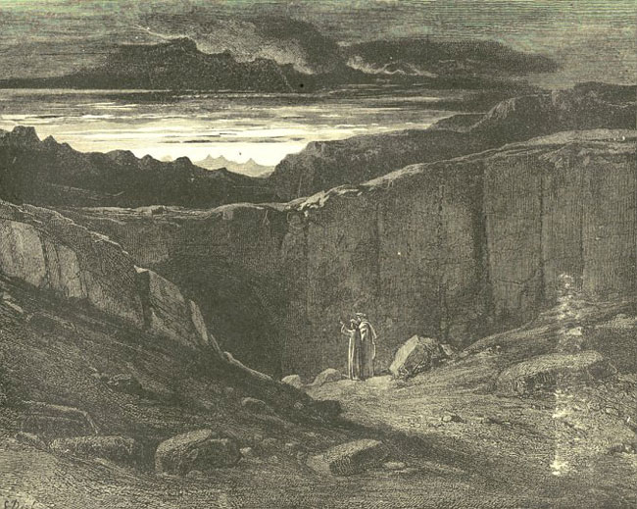

Dante and Virgil approaching the entrance to Hell (Gustave Doré, 1890)

Instructor: Mr. Prescott
Location: Chapel 016
Email: kprescott@andover.edu
Office Phone: (978) 749-4136
Cell Phone: (207) 504-6512

Course Description

In this course we will investigate fundamental questions of meaning through literature and the arts. Who am I and how am I related to ultimate realities? Why is there evil and suffering in the world? How can I live with integrity and joy? What is the role of imagination in human flourishing? These are other questions will be explored through story as represented in literature and other genres from across the globe.

Course Requirements, Evaluation, and Policies

I. Required Texts:

- Dante Alighieri, The Inferno, trans. John Ciardi (New York: Signet Classics, 2009).
- Margaret Attwood, The Handmaid’s Tale (New York: Anchor Books, 1986).

II. Evaluation

i. Classroom Participation (20%) – Much of this class will proceed as a seminar, which means careful reading of assigned work, regular attendance, and participation in class are all essential in order to succeed in the course. A separate handout/rubric will be distributed regarding expectations for classroom participation/discussion.

ii. Reflection Papers (10%) – In an effort to deepen our understanding of the assigned reading, students will be asked to complete weekly 1-page reflection papers (due on a night of the student’s choosing). A separate handout on reflection papers will be provided.

Iii. Essays (70%) – Three different analytical/argumentative essays will be assigned over the course of the term. More specific information about the nature of these essays will be provided closer to their corresponding due dates.

- Essay 1 (15%) – Due Thursday, December 15
- Essay 2 (25%) – Due Thursday, February 2
- Essay 3 (30%) – Due Tuesday, February 28

III. Extensions – Generally speaking, I do not grant extensions. In addition to allocating class time for papers, prompts are also handed out at least one week prior to the due date, so the expectation is that students will plan ahead and manage their time appropriately. The only exception to this policy is when a student has three or more major assignments due on the same day, in which case students are expected to follow the protocols outlined on p. 51 of the Blue Book under “Workload & Assignments” (which includes 24-hours advance notice).

IV. Late Work Policy – All written assignments are to be uploaded to Canvas as word documents (.doc) by the beginning of class. Any work uploaded after this point will be counted as late. Please note that technological difficulties are not an excuse for lateness. Anticipate that the printer will break, that files will be lost, or that your computer will die! Any work handed in after the due date will receive a grade no higher than a 4-.

V. Rewrite Policy – All students may choose to rewrite one essay per term. Revisions must be substantial; it is not sufficient simply to plug in the instructor’s feedback. Indeed, students electing to complete a revision are required to meet with me to discuss the revision process – please note that any revision completed without this meeting will not be accepted. The grade for the rewrite will be averaged with the initial grade to determine the new grade for the assignment. All rewrites are due one week after the initial essay is returned. Please note that I do not accept rewrites for unauthorized late essays.

VI. Absences - As noted above under Classroom Preparation/Participation, regular attendance is essential if one is to succeed in this course. However, I realize that this course is not your only commitment this term, just as I realize that circumstances inevitably arise that our outside of your control. First and foremost, I ask that you communicate with me (the earlier the better). Regarding Personal Time, I ask that students follow the procedures outlined on pp. 54-55 of the Blue Book (specifically, the request must be made at least 24 hours prior said class meeting). Please note that students are responsible for all announcements or changes made in class. Finally, in the event that an assignment is due on the day a student is sick (with an excused absence from the Health Center), said assignment will be due at the beginning of the next class meeting.

VII. E-mail – I will respond to all e-mail within 24 hours. However, please note that any e-mail sent after 8:00 PM will not receive a response until the following morning, so please plan ahead!

VIII. Religious Observances – Some students may wish to take part in religious observances that fall during the term. Should you have a religious observance that conflicts with participation in the course, please contact me as soon as possible to discuss appropriate accommodations.

IX. Disabilities – Students with learning, physical, or psychiatric disabilities who may require disability-related classroom accommodations are encouraged to see me as soon as possible to discuss your particular needs. All discussions will remain confidential, though I may consult Student Health Services to discuss appropriate implementation of any accommodation requested.

Schedule of Assignments
(Subject to Change)

Unit 1: The Inferno

“He is not simply taking a long walk: he is constructing a Universe.”
-John Ciardi on Dante

Week 1 – The Dark Wood of Error

Thursday, December 1 – Introduction & Overview
- No assigned readings

Friday, December 2 – The Dark Wood of Error
- Read: Dante Alighieri, “Cantos I and II”, The Inferno, trans., John Ciardi (New York: Signet Classics, 1954), 3-16

Week 2 – Visions of Hell

Tuesday, December 6 – The Upper Hell: Sins of Incontinence
- Read: Dante Alighieri, “Cantos III-VI”, The Inferno, trans., John Ciardi (New York: Signet Classics, 1954), 17-50.

Thursday, December 8 – The River Styx and the Walls of Dis
- Read: Dante Alighieri, “Cantos VII-IX”, The Inferno, trans., John Ciardi (New York: Signet Classics, 1954), 50-74.

Friday, December 9 – The Sins of the Lion
- Read: Dante Alighieri, “Cantos X and XI”, The Inferno, trans., John Ciardi (New York: Signet Classics, 1954), 75-91.
- Note: First Reflection Paper due by today’s class

Week 3 – The Inferno and Art

Tuesday, December 13 – Research Workshop
- Note: Class will meet at OWHL

Thursday, December 15 – Visualizing the Inferno
- Due: Essay #1

Friday, December 16 – Circle Seven: The Violent
- Read: Dante Alighieri, “Cantos XII and XIII”, The Inferno, trans., John Ciardi (New York: Signet Classics, 1954), 92-109.

Happy Winter Break!

Week 4 – The Geryon Principle

Tuesday, January 10 – Dante and Popular Culture
- No assigned readings

Thursday, January 12 – Dante and Sodomy
- Read: Dante Alighieri, Cantos 14-16, The Inferno, trans., John Ciardi (New York: Signet Classics, 1954), 110-133.

Friday, January 13 – The Failed Flyers
- Read: Ovid, Metamorphoses, trans. Anthony S. Kline (University of Virginia, 2000), 1.747-2.327, 8.183-235.
- Read: Dante Alighieri, Canto 17, The Inferno, trans., John Ciardi (New York: Signet Classics, 1954), 134-141.

Week 5 – The Eighth Circle of Hell

Tuesday, January 17 – Malebolge
- Read: Dante Alighieri, Cantos 18-20, The Inferno, trans., John Ciardi (New York: Signet Classics, 1954), 142-168.

Thursday, January 19 – Diabolical Semiosis: The Malebranche
- Read: Dante Alighieri, Cantos 21-23, The Inferno, trans., John Ciardi (New York: Signet Classics, 1954), 169-193.

Friday, January 20 – The Tale of Ulysses
- Read: Dante Alighieri, Cantos 26-27, The Inferno, trans., John Ciardi (New York: Signet Classics, 1954), 210-242.

Week 6 – The Ninth Circle of Hell

Tuesday, January 24 – The Linguistic Fall
- Read: Dante Alighieri, Cantos 30-32, The Inferno, trans., John Ciardi (New York: Signet Classics, 1954), 243-268.

Thursday, January 26 – Judaïcca
- Read: Dante Alighieri, Cantos 33-34, The Inferno, trans., John Ciardi (New York: Signet Classics, 1954), 269-285.

Friday, January 27 – Class Will Not Meet
- No assigned readings; work on essays

Unit 2: The Handmaid’s Tale

Week 7

Tuesday, January 31 – Writing Workshop
- Due: Rough Draft of Essay #2

Thursday, February 2 – The Women of Genesis
- Due: Essay #2

Friday, February 3 – Head of School Day!

Week 8

Tuesday, February 7 – The Republic of Gilead
- Read: Margaret Atwood, Chapters I-II, The Handmaid’s Tale (New York: Anchor Books, 1986), pp. 1-33.

Thursday, February 9 – The Dystopias of Gilead
- Read: Margaret Atwood, Chapters III-V, The Handmaid’s Tale (New York: Anchor Books, 1986), pp. 37-75.

Friday, February 10 – Panopticism in The Handmaid’s Tale
- Read: Margaret Atwood, Chapters VI-VII, The Handmaid’s Tale (New York: Anchor Books, 1986), pp. 79-106.

Week 9

Tuesday, February 14 – Complacency and Internment: Manzanar
- Read: Margaret Atwood, Chapters VIII-IX, The Handmaid’s Tale (New York: Anchor Books, 1986), pp. 109-147.

Thursday, February 16 – Dystopian Visions in Art and Literature
- Read: Margaret Atwood, Chapter X, The Handmaid’s Tale (New York: Anchor Books, 1986), pp. 151-188.

Friday, February 17 – Resisting the Gilead Within
- Read: Margaret Atwood, Chapter XI, The Handmaid’s Tale (New York: Anchor Books, 1986), pp. 191-195
- Note: Reading assignment for next Monday is longer than usual

Week 10

Tuesday, February 21 – Jezebel and Jezebel’s
- Read: Margaret Atwood, Chapter XII, The Handmaid’s Tale (New York: Anchor Books, 1986), pp. 199-255.

Thursday, February 23 – The Salvaging
- Read: Margaret Atwood, Chapters XIII-XV, The Handmaid’s Tale (New York: Anchor Books, 1986), pp. 259-295.

Friday, February 24 – Atwood’s New Testament
- Read: Margaret Atwood, “Historical Notes,” The Handmaid’s Tale (New York: Anchor Books, 1986), pp. 299-311.

Week 11 – Finals Week

Monday, February 27 – Writing Workshop (Optional)
- Note: Mr. Prescott will provide comments on drafts that are uploaded to Canvas by 8:00 PM on Sunday, February 26

Tuesday, February 28 – Essay #3 Due
- Due: Essay #3

